


Korea Lunar Exploration Program
DTNPL Qualification Model
Thermal Cycling Test Procedure

Date: 19 Feb. 2019 | Doc. No: KPLO-D0-550-450  Issue: 1.0  Total page: 43

Superseding Revised

Reviewed By:  Chang-Soo Lee Date  DTN Product Assurance, Lumir  Kyung-Rak Lee Date  DTN System Engineer, ETRI |  | Prepared By:  Sun-Ku Kim Date  DTN Engineer, Lumir  Dae-Soo Oh Date  DTN Project Manager, Lumir
Reviewed By:  Chol-Oh Jeong Date  DTN Product Assurance, ETRI |  | Jin-Ho Jo Date  DTN Project Leader, ETRI

Original CDMO Release__________________

Revision/Change Records
Version | Date | Revision/Change Description | Pages
P-00 | 2017. 11. 06. | Draft | All
P-01 | 2017. 11. 24. | Test Spec Updated | All
1.0 | 2019. 02. 19 | QM Test Spec Updated | All

Documents Tree

Contents

1. Introduction 8
1.1. Purpose and Scope 8
1.2. Applicable Documents 8
1.2.1. ETRI Documents 8
1.2.2. Reference Documents 8
1.3. Abbreviations 8
2. Test Article 10
2.1. DTNPL Configurations 10
2.1.1. CON_PWR 10
2.1.2. CON_COMM 10
2.1.3. CON_DEBUG 11
2.2. Verification Cross Reference 12
2.3. Notification for Qualification and Acceptance Tests 12
3. Conditions 12
3.1. Test personnel 12
3.2. Precaution and Warnings 13
4. Test Setup 14
4.1. Test facility 14
4.2. Thermal Chamber Setup 14
4.3. Test Software 15
4.4. Test Preparation 15
4.4.1. Control and Measuring Equipment 15
5. Test Description 16
5.1. Thermal Test Levels 16
5.2. Temperature Profile 16
5.3. Test Parameters 17
6. Test Procedures 17
6.1. Test preparation 23
6.2. Ambient Test Before Thermal Cycling Test 24
6.3. Highest Non-Operational Temperature 25
6.4. First Hot Plateau 26
6.5. Lowest Non-Operational Temperature 27
6.6. First Cold Plateau 28
6.7. Intermediate Cycle 29
6.7.1. 2nd Cycle 29
6.7.2. 3rd Cycle 31
6.7.3. 4th Cycle 33
6.8. Last Hot Plateau 35
6.9. Last Cold Plateau 36
6.10. Back to Ambient Temperature 37
6.11. Functional Test After Thermal Cycling 38
6.12. Remove DTNPL From Chamber 39
7. Test Conclusion 39

Figures

Figure 2-1 DTNPL Configurations 10
Figure 2-2 Power Connector 10
Figure 2-3 Commend Connector 11
Figure 2-4 Debug Connector 12
Figure 4-1 Test Room Layout 14
Figure 4-2 Thermal Chamber Layout 14
Figure 4-3 Location of Thermal Sensors 15
Figure 5-1 Temperature Design and Test Limits 16
Figure 5-2 Timeline for Thermal Cycle Profile 17

Tables

Table 4-1 Control Thermal Sensors 15
Table 4-2 Measurement Thermal Sensors 15
Table 5-1 DTNPL Test Temperature Limits 16
Table 6-1 Thermal Cycle Procedure and Setting Prameters 18

Introduction

Purpose and Scope
This document defines the Thermal Cycling test procedure for the DTN payload.
The purpose of this is to demonstrate that the DTN payload is working as expected under the required environmental conditions. During the Thermal Test a representative collection of functionality and performance test will be performed to check interfaces and hardware related functions.

Applicable Documents

ETRI Documents
 | Document Number | Document Title
AD01 | KPLO-D0-550-000 | System Requirement of DTN Payload
AD02 | KPLO-D0-550-001 | System Specification of DTN Payload
AD03 | KPLO-SP-320-002 | KPLO Environmental Design and Test Specification

Reference Documents
 | Document Number | Document Title
RD01 | MIL-STD-1540C | Test Requirements for Launch, Upper-Stage, and Space Vehicles
RD02 | PSS-01-801 | Test Requirements Specification for Space Equipment
RD03 | ECSS-E-10-03-A | ECSS Space Engineering-Testing

Abbreviations
AMS | Asynchronous Message Service
BP | Bundle Protocol
BSS | Bundle Streaming Service
CCSDS | Consultative Committee for Space Data Systems
CFDP | CCSDS File Delivery Protocol
DCC | DTN Control Center
CRC | Cyclical Redundancy Check
DMA | Direct Memory Access
DTN | Delay(Disruption) Tolerant Network
DTNPL | DTN Payload
EOD | End of Data
EOF | End of File
FW | Firm Ware
FSW | Flight Software
ION | Interplanetary Overlay Network
KPLO | Korea Pathfinder Lunar Orbiter
LCM | Lander Communication Model
LTP | Lickliter Transmission Protocol
OBC | On Board Computer
PDHU | Payload Data Handling Unit
RCM | Rover Communication Model
DTNPL | Single Board Computer
SOD | Start of Data
SOF | Start of File
SOH | Start of Head
TBC | To Be Confirmed
TBD | To Be Defined
TC | Tele-command
TCP | Transmission Control Protocol
TM | Telemetry
UART | Universal Asynchronous Receiver Transmitter

Test Article
The objective of this Thermal Cycling Test is to demonstrate compliance of the DTNPL with the requirements from the KPLO Requirements Specification [AD 03]
This test procedure shall be used for test of the DTNPL QM.

DTNPL Configurations
The unit under test is shown in the following figures:

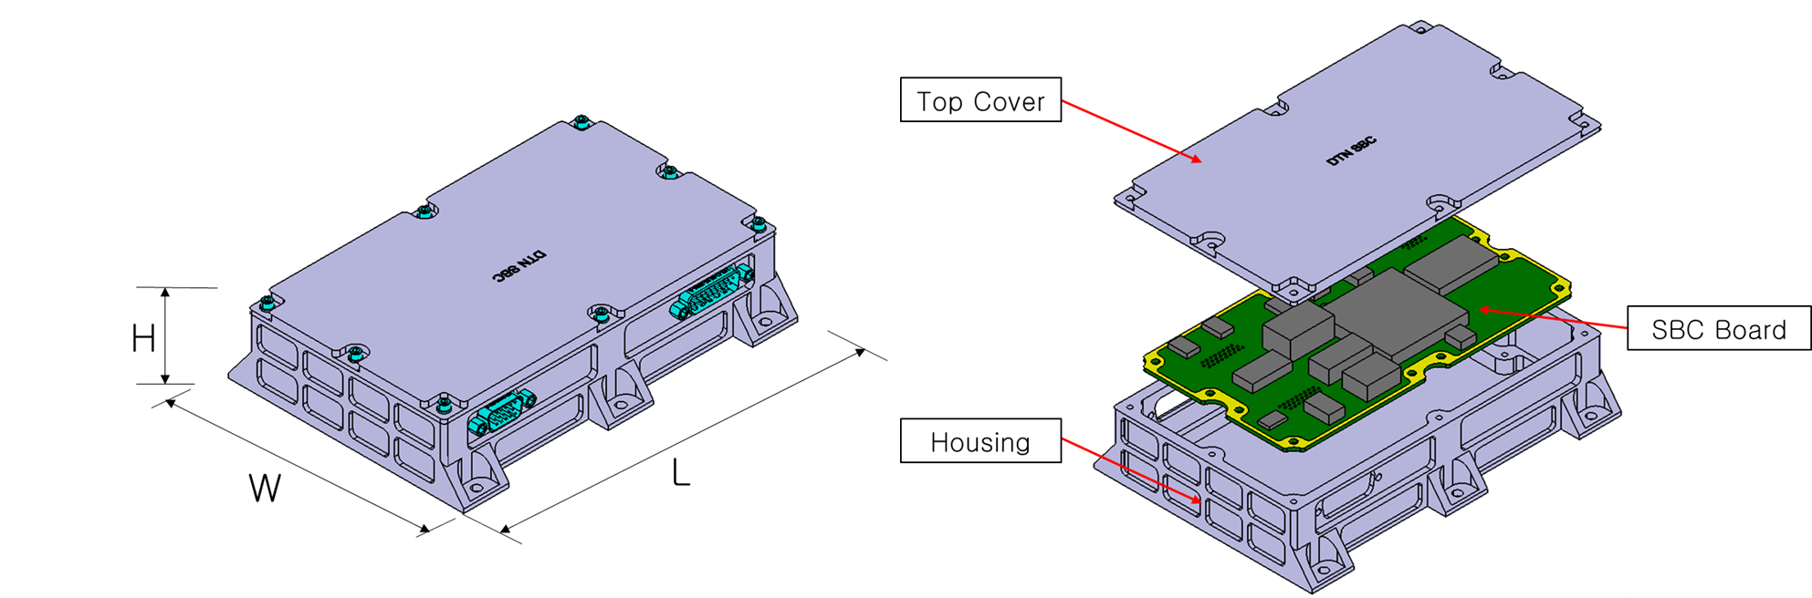
Figure 2-1 DTNPL Configurations

Dimension: 120 x 170 x 39 ㎜
Weight: 1.23 kg

CON_PWR
- Power Input (2 lines for +28V, 2 lines for RTN)
Figure 2-2 Power Connector

CON_COMM
- 1 UART for OBC
- 2 USRT for PDHU(P/R)
- 1 Bi-level Status for OBC
- 1 Bi-level Command for OBC

Figure 2-3 Commend Connector

CON_DEBUG
- 1 JTAG for Firmware Uploading
- 1 RS422 for Debugging UART
- 1 SpaceWire for Image Uploading, 40 Mbps (TBR)
- 1 GPIO for Debugging
- 1 SPI for DT10 (S/W Test Platform)
Figure 2-4 Debug Connector

Verification Cross Reference
The requirements which have to be verified by a successful performance in the test and its relevant test steps are given below:

Applicable Doc. | Requirement | Verified by Test Step | Compliance
KPLO-SP-320-002 | Environmental Design | All | C

Notification for Qualification and Acceptance Tests
This test procedure shall be approved by the ETRI prior to performance of the test, either by signature on cover page of by performance of a dedicated Test Readiness Review(TRR).

Conditions

Test personnel
The personnel required for the performance of the tests is listed below:

Test Engineers
The test engineers are responsible for:
- Operation of measuring instrumentation, data acquisition, data handling, data recording
- Identification and compilation of data sheet
- Safety precaution for test articles
- Test personnel to be present in the test area
- The accuracy of the measured values & Data report

Test Manager
The test manager is responsible for:
- Test articles and technical aspects of the test performance
- Record the correct software version for test article and EGSE
- Examination of disturbances
- Test article integration and handling
- Test performance
- Evaluation of test results & Providing of test reports

Quality Assurance Engineer
The QA engineer is responsible for:
- Surveillance of test equipment according to regulations as well as the test procedure
- Statement that the test articles to be tested have passed all checks before testing
- Checking the identification markings on the test articles
- Supervision of the proceeding with respect to quality assurance performance

The customer has the fight to participate or observe the test
Responsibility | Company /Dep. | Name
Test Engineer | Lumir / R&D | Kim, Sun-Ku
Test Manager | Lumir / R&D | Oh, Dae-Soo
Quality Assurance Engineer | Lumir / PA | Lee, Chang-Soo
Facility Engineer / Operator | Lumir / QA | Choi, Jae-woong

Precaution and Warnings
For all testing and handling, ESD requirements concerning personnel, facilities and test equipment shall be regarded.
No special hazard exists during the test.

The following precautions apply:
- Only trained personnel are allowed to handle the test specimen.
- A test cable or breakout box shall never be connected of disconnected when the test specimen is powered.
- Correct set-up of the test equipment has to be checked carefully prior to the connection/switch-on of flight hardware, e.g. bonding, grounding, voltages, current limiters, etc.
- The test specimen shell be protected by a clean, antistatic bag all the time no activities are performed at the hardware.

Test Setup

Test facility
The ambient conditions within the test rooms shall be in compliance with the clean room class 100,000 or less.

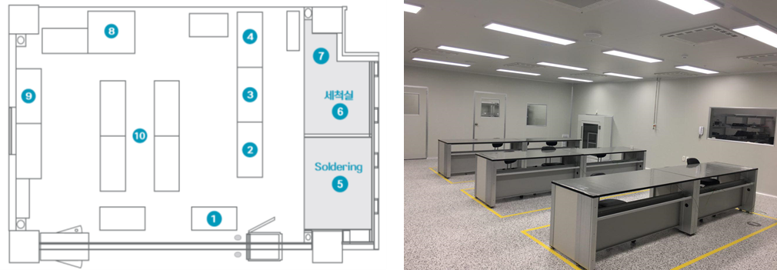
Figure 4-1 Test Room Layout

Thermal Chamber Setup
For Thermal Cycling Test the following setup will be used:

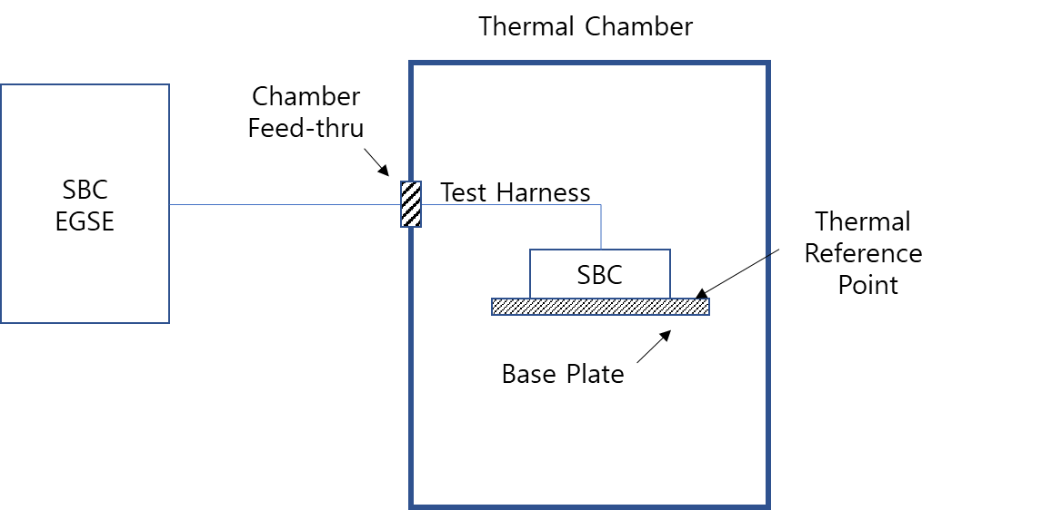
Figure 4-2 Thermal Chamber Layout

Test Software
Software version used:

Test Preparation
The test harness shall be connected from DTNPL ESGE to the DTNPL through the Thermal Chamber feed-thru. During the test, the DTNPL shall be operated in a representative manner.

Control and Measuring Equipment
The thermal plate and the DTNPL unit will be equipped with temperature sensors(Thermocouples) on the positions defined in the descriptions below. The actual sensor positions will be noted after fixing on the equipment as given in the sensor location plan at the following tables:

Table 4-1 Control Thermal Sensors
No. | Position | Remark
C1 | Base Plate | Defined by Test Engineer
C2 | Base Plate (optional) | Defined by Test Engineer

Table 4-2 Measurement Thermal Sensors
No | Position | Remark
T1 | DTNPL Top Cover
T2 | DTNPL Case Side

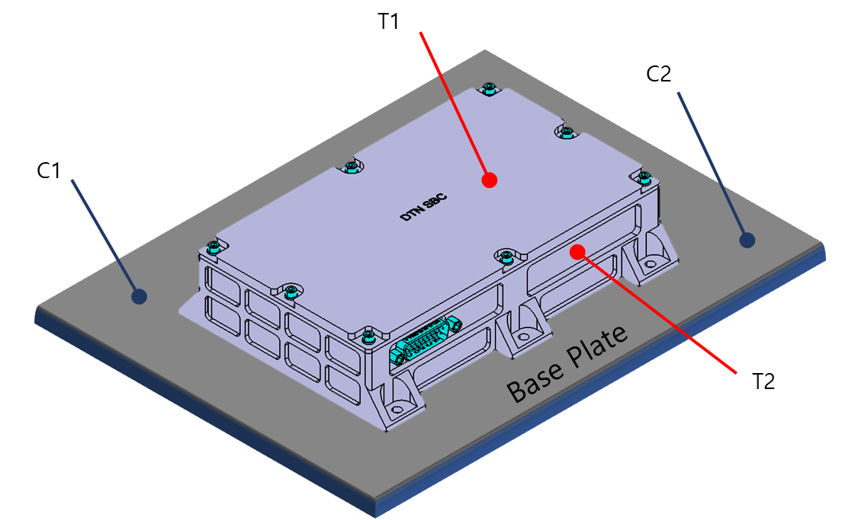
Figure 4-3 Location of Thermal Sensors

Test Description

Thermal Test Levels
The nominal sequence of the thermal cycles is depicted in and temperature range for tests are summarized in

Table 5-1 DTNPL Test Temperature Limits
 | Temperature Limits (degree C)
Equipment | Proto-flight (Operating) Range |  | Cold  Turn-On | Acceptance  (Operating)  Range |  | Survival  (Non-Operating)  Range
 | Min | Max |  | Min | Max | Min | Max
DTNE_DTNPL | -30 | 60 | -30 | -20 | 50 | -35 | 70

Figure 5-1 Temperature Design and Test Limits

Temperature Profile
The DTNPL shall be subjected to temperature cycles as described in the following figure. DTNPL operation over the range of temperatures shall be demonstrated at specific points during the thermal cycling test according to the following figure.

Figure 5-2 Timeline for Thermal Cycle Profile

Test Parameters
The following test parameters shall apply:
Temperature range : As defined in the applicable equipment specification and Table 5-1
Temperature exposure : As described in Table 5-1 and Figure 5-2
Temperature change rate : 3 to 5°C/minute

Test Procedures
The DTNPL shall have a full functional test performed at ambient temperature prior to beginning the thermal cycling test. Thermal soak duration shall be at least 6 hours at the hot temperatures and 6 hours at
the cold temperatures during the first and last cycle (Figure 4-1). Intermediate cycles shall give at least 1 hour soak at the hot and cold temperatures. During the thermal soak, the unit shall be turned off until the temperature stabilizes and turn on. Remaining on until the next soak period off on sequence. Measurement of thermal soak duration shall begin at the time of unit turn on (Figure 4-1).
Functional tests shall be conducted after the DTNPL temperature have stabilized at hot and cold temperatures during the first and last thermal cycle, and after return to ambient. During the remainder of the test, electrical and electronic units, including all redundant circuits and paths, shall be cycled through various operation modes.
DTNPL shall meet their performance requirements within specification over the maximum expected temperature range extended at both temperatures by 10°C. The final thermal cycle should employ a sufficiently slow temperature transition to permit a complete functional check to be repeated at essentially all temperatures.
Moisture condensation in side of DTNPL shall be prevented.

Table 6-1 Thermal Cycle Procedure and Setting Prameters
 | Setting Tempe (℃) | Setting Time (H.M.S) | Power Control | Remark
Start | Ambient |  | Turn on for function test | Ambient
1 | 70 | 00.15.00 | Turn off @ After 10minutes | First Cycle
2 | 70 | 01.00.00 |  | First Cycle
3 | 60 | 00.06.00 |  | First Cycle
4 | 60 | 06.30.00 | Turn on @ After 30minutes | First Cycle
5 | -35 | 00.35.00 | Turn off @ After 20minutes | First Cycle
6 | -35 | 01.00.00 |  | First Cycle
7 | -30 | 00.05.00 | Turn on @ After 3minutes | First Cycle
8 | -30 | 06.00.00 |  | First Cycle
9 | 60 | 00.23.00 | Turn off @ After 23minutes | 2nd Intermediate Cycle
10 | 60 | 01.30.00 | Turn on @ After 10minutes | 2nd Intermediate Cycle
11 | -30 | 00.23.00 | Turn off @ After 23minutes | 2nd Intermediate Cycle
12 | -30 | 01.30.00 | Turn on @ After 10minutes | 2nd Intermediate Cycle
13 | 60 | 00.23.00 | Turn off @ After 23minutes | 3rd Intermediate Cycle
14 | 60 | 01.30.00 | Turn on @ After 10minutes | 3rd Intermediate Cycle
15 | -30 | 00.23.00 | Turn off @ After 23minutes | 3rd Intermediate Cycle
16 | -30 | 01.30.00 | Turn on @ After 10minutes | 3rd Intermediate Cycle
17 | 60 | 00.23.00 | Turn off @ After 23minutes | 4th Intermediate Cycle
18 | 60 | 01.30.00 | Turn on @ After 10minutes | 4th Intermediate Cycle
19 | -30 | 00.23.00 | Turn off @ After 23minutes | 4th Intermediate Cycle
20 | -30 | 01.30.00 | Turn on @ After 10minutes | 4th Intermediate Cycle
21 | 60 | 00.23.00 | Turn off @ After 23minutes | Last Cycle
22 | 60 | 06.30.00 | Turn on @ After 30minutes | Last Cycle
23 | -30 | 00.23.00 | Turn off @ After 23minutes | Last Cycle
24 | -30 | 06.30.00 | Turn on @ After 30minutes | Last Cycle
25 | 35 | 00.18.00 |  | Ambient
26 | 35 | 00.30.00 |  | Ambient
27 | 20 | 00.05.00 |  | Ambient
End | Ambient |  | Turn off After function test | Ambient

Table 6-2 Test Procedure Sequence
Step | Test Procedure | Remark
1 | Configure the test environment as shown in the ‘Figure 4-2’.
2 | Power Input  - Power Supply Setting : 28V / 0.50A  - Nominal Voltage : 28V  - Nominal Current : <0.50A
2 | Scan Chain Pass  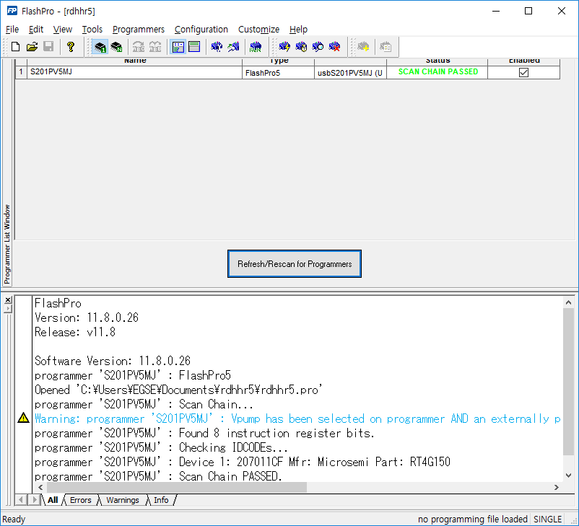 | O
4 | GRMON Connection PASS  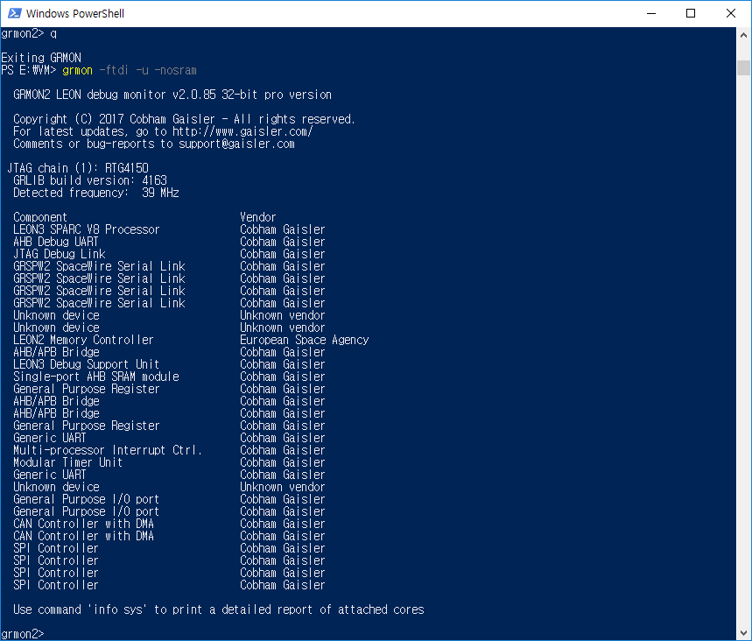
5 | F/W execution PASS  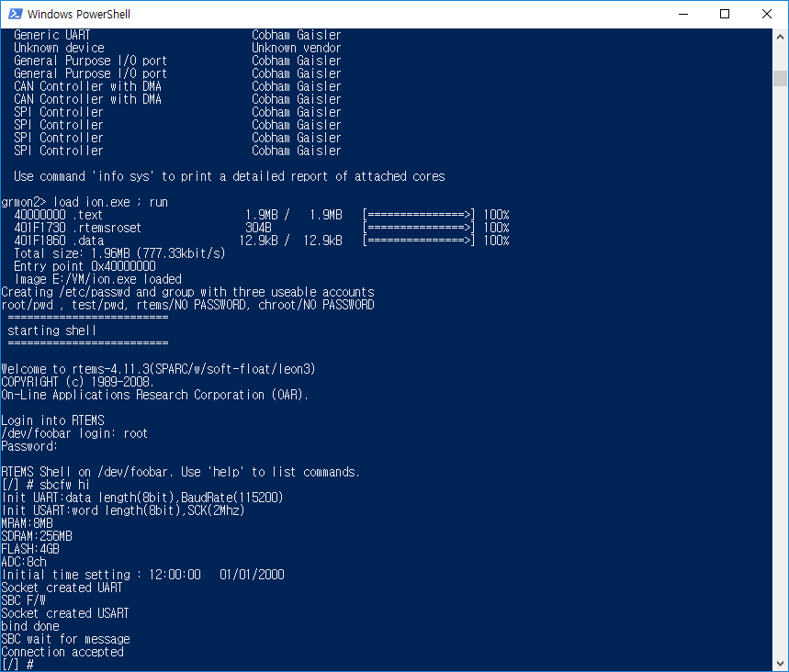 | O
6 | MATLAB DTN_EGSE.m execution PASS  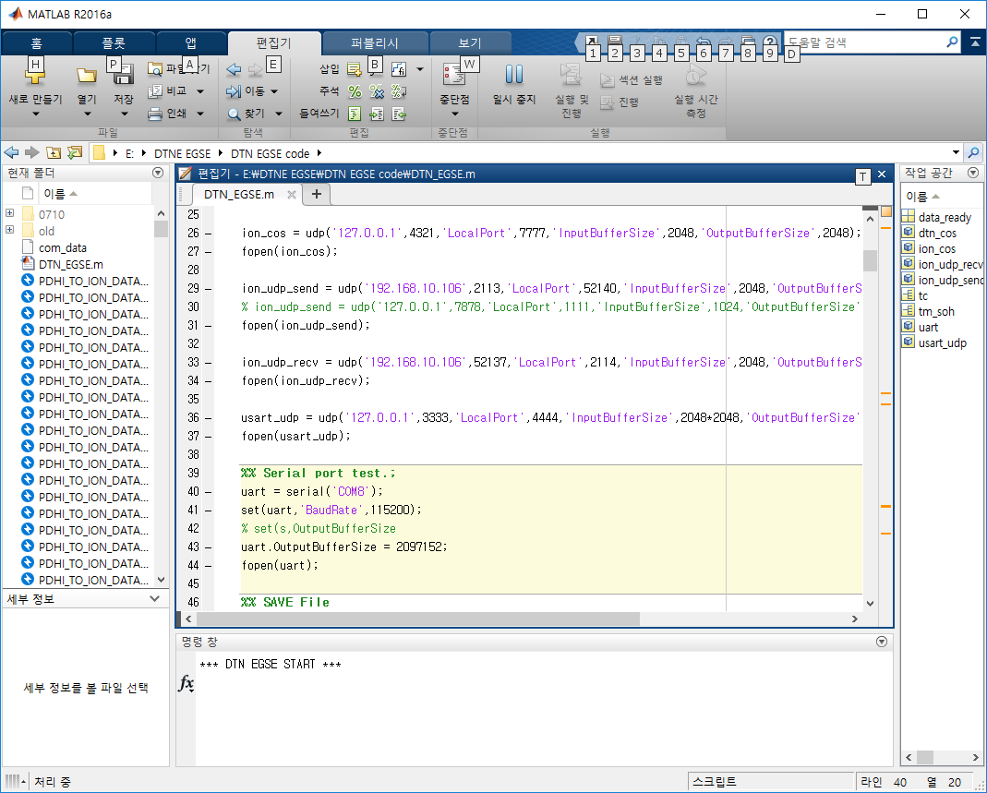 | O
7 | Set up environment to receive data by running ‘Data Center’ Software.  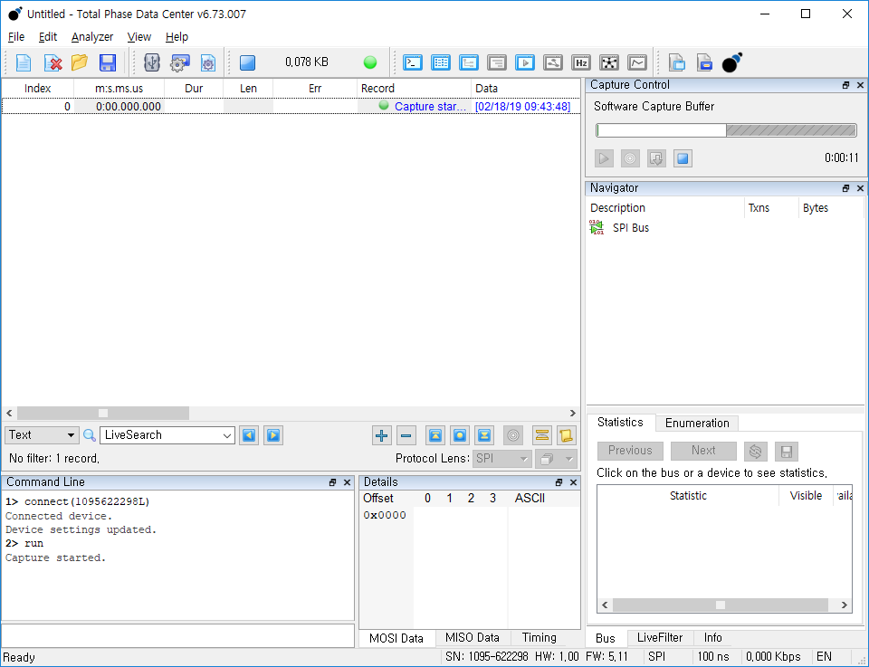
8 | After COSMOS Software execution,, In the 층 packet window, select 1_MULTI_Test and click the send button.  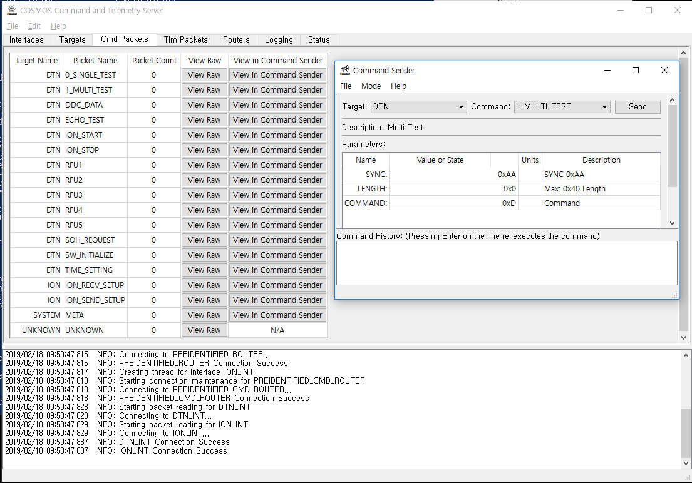 | O
9 | Storing data when data comes in ‘Data center’ Software.  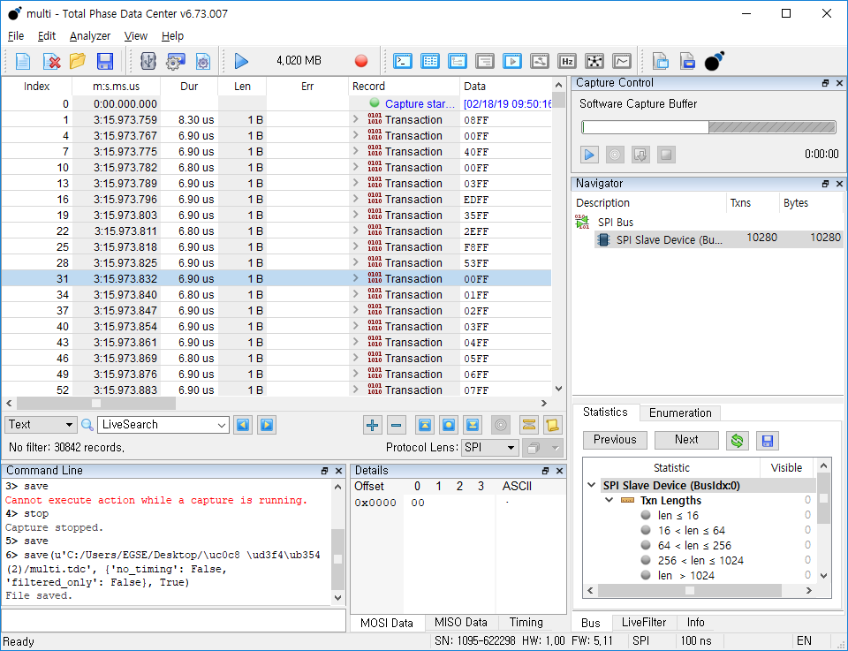 | O

Test preparation

Start Date : ________________________ / Time : ________________________

(1) | Fill out test environment conditions | Pass / Fail | Signe
(2) | Fill out test personnel | Pass / Fail | Signe
(3) | Check test articles and fill out, check, and sign Test Article list above | Pass / Fail | Signe
(4) | Check test equipment and fill out, check, Test Equipment list above setup complete | Pass / Fail | Signe
(5) | Power off for each test article and test equipment switched off Install DTNPL in Thermal Cycling chamber | Pass / Fail | Signe
(6) | Mount DTNPL onto the base plate by fixing of screws. | Pass / Fail | Signe
(7) | Attach temperature sensors according to chapter 4.4.1 | Pass / Fail | Signe
(8) | Check that connector savers installed on all used interfaces | Pass / Fail | Signe
(9) | Connect harness to DTNPL and connect harness to chamber feed- through | Pass / Fail | Signe
(10) | Take pictures of the mounted DTNPL when ready for thermal cycling test | Pass / Fail | Signe
(11) | Start recording temperature measurement points and chamber temperature continuously | Pass / Fail | Signe
(12) | Correlate time, Temperature and test results exactly | Pass / Fail | Signe

End Date: / Time:

Test Engineer: (Signature)

Ambient Test Before Thermal Cycling Test

Start Date: / Time:
Temperature: ℃ (19 ~ 25℃)
Humidity: % (35 ~ 55℃)

With feed assembly in the thermal chamber, the functional test should be performed at the ambient condition in accordance with the following sequence and record the test results per the indicated method.

 | Test Description | Nominal Value | Actual Value
(1) | Measure input current | Under 0.5A
(2) | Measure input voltage | 28V
(3) | Perform Functional test in ‘Table 6-2’ | Pass / Fail

End Date: / Time:

Test Engineer: (Signature)

Highest Non-Operational Temperature

Start Date: / Time:

- Increase the temperature in the T/C chamber to the maximum test temperature(+70℃)

- Turn off DTNPL at + 60℃ during thermal transition
Turn off time:

- Wait until the temperature of Thermal Chamber reaches +70℃

 | Temperature
 | C1 | C2 | T1 | T2 | T3
Start
End

End Date: / Time:

Test Engineer: (Signature)

First Hot Plateau

Start Date: / Time:

- Start thermal transition setting to Temperature(+60℃)
 | Temperature
 | C1 | C2 | T1 | T2 | T3
Start
End

- Wait until the temperature of the Thermal Chamber reaches +60℃ and switch DTNPL on.
Turn on time:

Test Description | Nominal Value | Actual Value
Measure input current | Under 0.5A
Measure input voltage | 28V
Perform full Functional Test of DTNPL | Pass / Fail

- Hold temperature for at least 6 hours.

End Date: / Time:

Test Engineer: (Signature)

Lowest Non-Operational Temperature

Start Date: / Time:

- Start thermal transition by decreasing temp setting down to -35℃.

- Turn off DTNPL at -30℃ during thermal transition
Turn off time:

- Wait until the temperature of Thermal Chamber reaches -35℃

 | Temperature
 | C1 | C2 | T1 | T2 | T3
Start
End

- Hold temperature for at least 1 hour

End Date: / Time:

Test Engineer: (Signature)

First Cold Plateau

Start Date: / Time:

- Start thermal transition by increasing temp setting up to -30℃.

- Turn on DTNPL at -30℃ during thermal transition
Turn on time:

- Wait until the temperature of the Thermal Chamber reaches -30℃

 | Temperature
 | C1 | C2 | T1 | T2 | T3
Start
End

- Perform short Functional Test of DTNPL

Test Description | Nominal Value | Actual Value
Measure input current | Under 0.5A
Measure input voltage | 28V
Perform full Functional Test of DTNPL | Pass / Fail

- Hold temperature for at least 5 hours.

End Date: / Time:

Test Engineer: (Signature)

Intermediate Cycle

2nd Cycle

Start Date: / Time:

- Start thermal transition by increasing temp setting up to +60℃.

 | Temperature
 | C1 | C2 | T1 | T2 | T3
+55℃.
-25℃.

- When base plate temperature reaches +60℃ switch DTNPL off
Turn off time:

- Hold temperature for at least 10 minutes and Turn on DTNPL
Turn on time:

- Perform short Functional Test of DTNPL

Test Description | Nominal Value | Actual Value
Measure input current | Under 0.5A
Measure input voltage | 28V
Perform full Functional Test of DTNPL | Pass / Fail

- Hold temperature for at least 1 hour.

- Start thermal transition by decreasing temp setting down to -30℃.

- When Thermal Chamber reaches -30℃ switch DTNPL off
Turn off time:

- Hold temperature for 10 minutes and switch DTNPL on
Turn on time:

- Perform short Functional Test of DTNPL

Test Description | Nominal Value | Actual Value
Measure input current | Under 0.5A
Measure input voltage | 28V
Perform full Functional Test of DTNPL | Pass / Fail

- Hold temperature for at least 1 hour.

End Date: / Time:

Test Engineer: (Signature)

3rd Cycle

Start Date: / Time:

- Start thermal transition by increasing temp setting up to +60℃.

 | Temperature
 | C1 | C2 | T1 | T2 | T3
+55℃.
-25℃.

- When base plate temperature reaches +60℃ switch DTNPL off
Turn off time:

- Hold temperature for at least 10 minutes and Turn on DTNPL
Turn on time:

- Perform short Functional Test of DTNPL

Test Description | Nominal Value | Actual Value
Measure input current | Under 0.5A
Measure input voltage | 28V
Perform full Functional Test of DTNPL | Pass / Fail

- Hold temperature for at least 1 hour.

- Start thermal transition by decreasing temp setting down to -30℃.

- When Thermal Chamber reaches -30℃ switch DTNPL off
Turn off time:

- Hold temperature for 10 minutes and switch DTNPL on
Turn on time:

- Perform short Functional Test of DTNPL

Test Description | Nominal Value | Actual Value
Measure input current | Under 0.5A
Measure input voltage | 28V
Perform full Functional Test of DTNPL | Pass / Fail

- Hold temperature for at least 1 hour.

End Date: / Time:

Test Engineer: (Signature)

4th Cycle

Start Date: / Time:

- Start thermal transition by increasing temp setting up to +60℃.

 | Temperature
 | C1 | C2 | T1 | T2 | T3
+55℃.
-25℃.

- When base plate temperature reaches +60℃ switch DTNPL off
Turn off time:

- Hold temperature for at least 10 minutes and Turn on DTNPL
Turn on time:

- Perform short Functional Test of DTNPL

Test Description | Nominal Value | Actual Value
Measure input current | Under 0.5A
Measure input voltage | 28V
Perform full Functional Test of DTNPL | Pass / Fail

- Hold temperature for at least 1 hour.

- Start thermal transition by decreasing temp setting down to -30℃.

- When Thermal Chamber reaches -30℃ switch DTNPL off
Turn off time:

- Hold temperature for 10 minutes and switch DTNPL on
Turn on time:

- Perform short Functional Test of DTNPL

Test Description | Nominal Value | Actual Value
Measure input current | Under 0.5A
Measure input voltage | 28V
Perform full Functional Test of DTNPL | Pass / Fail

- Hold temperature for at least 1 hour.

End Date: / Time:

Test Engineer: (Signature)

Last Hot Plateau

Start Date: / Time:

- Start thermal transition setting to Temperature(+60℃)
 | Temperature
 | C1 | C2 | T1 | T2 | T3
Start
End

- Wait until the temperature of the Thermal Chamber reaches +60℃ and switch DTNPL on.
Turn on time:

Test Description | Nominal Value | Actual Value
Measure input current | Under 0.5A
Measure input voltage | 28V
Perform full Functional Test of DTNPL | Pass / Fail

- Hold temperature for at least 6 hours.

End Date: / Time:

Test Engineer: (Signature)

Last Cold Plateau

Start Date: / Time:

- Start thermal transition by increasing temp setting up to -30℃.

- Turn on DTNPL at -30℃ during thermal transition
Turn on time:

- Wait until the temperature of the Thermal Chamber reaches -30℃

 | Temperature
 | C1 | C2 | T1 | T2 | T3
Start
End

- Perform short Functional Test of DTNPL

Test Description | Nominal Value | Actual Value
Measure input current | Under 0.5A
Measure input voltage | 28V
Perform full Functional Test of DTNPL | Pass / Fail

- Hold temperature for at least 5 hours.

End Date: / Time:

Test Engineer: (Signature)

Back to Ambient Temperature

Start Date: / Time:

- Start thermal transition by increasing temp setting up to +35℃.

- Check the temperature as it reaches +35℃.

- Hold temperature for at least 30 minutes.

- Start thermal transition by decreasing temp setting down to +25℃.

- Check the temperature as it reaches +25℃.

 | Temperature
 | C1 | C2 | T1 | T2 | T3
+35℃.
+25℃.

End Date: / Time:

Test Engineer: (Signature)

Functional Test After Thermal Cycling

Start Date: / Time:

- Perform Full Functional Test of DTNPL

Test Description | Nominal Value | Actual Value
Measure input current | Under 0.5A
Measure input voltage | 28V
Perform full Functional Test of DTNPL | Pass / Fail

- Switch DTNPL off.
Turn off time:

- Stop recording chamber data

End Date: / Time:

Test Engineer: (Signature)

Remove DTNPL From Chamber

Start Date: / Time:

- Disconnect Test Harness from DTNPL EGSE and chamber feed-through.

- Disconnect TC Harness from DTNPL EGSE and chamber feed-through.

- Remove temperature sensors.

- Dismount DTNPL Base plate fixations.

- Remove DTNPL from Chamber.

End Date: / Time:

Test Engineer: (Signature)

Test Conclusion
The PA shall review the test data for acceptance of the thermal Cycling test.
The following sign off is verification that the test article has satisfactorily passed thermal Cycling test.

PA: Date:

